Nutrition is the supply of food required by the organism and cells. Our body needs nutrients for its correct functioning. The essential nutrients are carbohydrates, minerals, vitamins, fats, fiber, and proteins.
Food is divided in two groups healthy and junk food.

HEALTHY FOOD
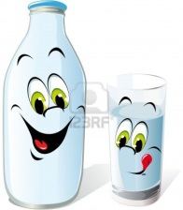

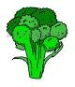
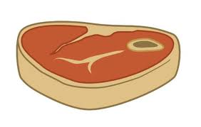
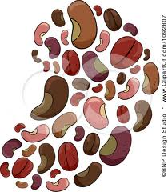
meet broccoli egg milk beans

JUNK FOOD
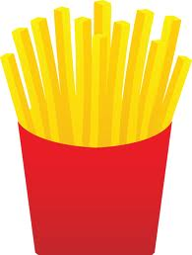
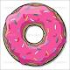
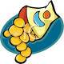
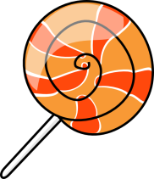
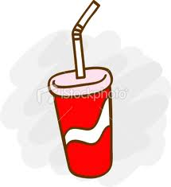

coke french fries candy chips donuts

